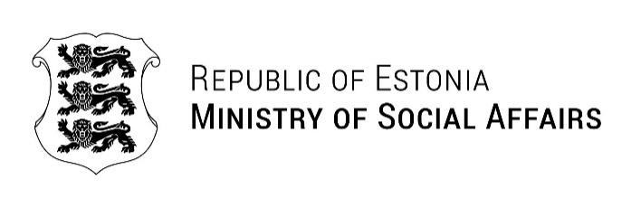
Andrii Shmorgun  Ministry of Health of Ukraine  shmorgun.ak@gmail.com | Our ref 02.09.2026 No 1.4-2/2108-1
Invitation letter

Ministry of Social Affairs of Estonia invates Mr Taras Skorobahatko, Chief Specialist of the Expert Group on State Policy Formation in the Gambling and Lottery Sector, Directorate of Digital Economy, Ministry of Digital Transformation of Ukraine to a study visit to Estonia on 7-8 September 2026. The programme of the study visit will focus on Estonia’s experiences and practices in addiction prevention and mental health promotion.

Yours sincerely,

Agne Nettan-Sepp
Head of European Union Affairs and
International Cooperation Department

Copy to: Embassy of Ukraine in the Republic of Estonia

Eha.Lannes@sm.ee

